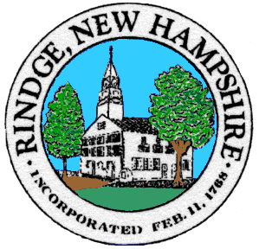
ZONING BOARD OF ADJUSTMENT
30 PAYSON HILL ROAD
RINDGE NH 03461
PH. (603) 899-5181x105 FAX (603) 899-2101 TDD 1-800-735-2964
www.rindgenh.gov

ZONING BOARD OF ADJUSTMENT
PUBLIC NOTICE
April 28, 2026 – 7:00pm

Notice is hereby given under RSA 676:7 I (b) that the Zoning Board of Adjustment will hold a public hearing on Tuesday, April 28th, 2026, at 7:00 p.m. at Town Offices, 30 Payson Hill Road, Rindge, NH, concerning the following applications:
ZBA Case# 2026-03: A Special Exception is requested as specified in the Wetlands Conservation District Ordinance, Section 6, of the Rindge Zoning Ordinance to permit Wetlands Disturbance of 0.38 acres as well as work within the 50ft buffer of said wetlands as part of construction of a proposed 37-resident subdivision at a property located at Tax Map 4, Lot 3-1.

ZBA Case# 2026-04: A Special Exception is requested as specified in Article V, Section A-3 of the Rindge Zoning Ordinance to permit the construction of up to 16 multi-family units within 4 townhouse-style structures on a property located at Tax Map 4, Lot 3-1

Other business that may come before the Board.
- Board deliberation for submission deadline of supplemental materials in the rehearing of Case #2025-15 concerning the following:
  - ZBA Case# 2025-16: A Variance is requested from Article V, Section B-1 of the Rindge Zoning Ordinance to permit the creation of a lot with less than the required minimum frontage located at Map 16 Lot 7-0 in the Residential/Agricultural District at 102 Hubbard Hill Road and owned by Jason Gorman.
All interested parties and their representatives are invited to attend. If you cannot attend these hearings and would like your opinion(s) entered into the record for these cases, you may write a letter to the Board documenting your input/testimony. Please give any documentation to the Executive Secretary to be presented at the Zoning Board of Adjustment Public Hearing.

